VMware Cloud Experience: Configuring VLC for Holodeck

Table of contents

VCF Experience Program Lab Overview 3

Configuring VLC for use in Holodeck 4

Overview 4

Prerequisites 4

Task 1: Configure ESXi host networking 6

Task 2a: Deploy nested jump host 7

Task 2b: Configure jump host networking 12

Task 3a: Configure internet access with PFsense 17

Task 4: Deploy VCF using VLC 37

# VCF Experience Program Lab Overview

The VMware Cloud Foundation (VCF) Experience Program is designed to provide a hands-on experience highlighting how VCF delivers a *Cloud Operating Model* for customer managed on premises environments, capable of hosting traditional and modern applications. This Experience Program guide is intended for use with a VCF Lab Constructor (VLC) based nested environment built using the Automated Holodeck config.

### Credentials

The following credentials are used in this lab. For your convenience, links to all management interfaces are in the bookmark bar of Google Chrome in your lab environment.

* **SDDC Manager**
  + Username: administrator@vsphere.local
  + Password: VMware123!
* **vCenter Server Admin Console**
  + Username: root
  + Password: VMware123!
* **vSphere Web Client**
  + Username: administrator@vsphere.local
  + Password: VMware123!
* **VMware NSX Manager**
  + Username: admin
  + Password NSX-T: VMware123!VMware123!
* **vRealize Automation Cloud Assembly**
  + Username: configadmin
  + Password: VMware123!
* **Windows Console (Jump Host)**
  + Username: administrator
  + Password: VMware123!
* **Opencart Apache and MqSQL VMs**
  + Username: ocuser
  + Password: VMware123!

# Configuring VLC for use in Holodeck Multi Region

## Overview

The “VCF Holodeck Multi Region” configuration is an opinionated nested VMware Cloud Foundation configuration used as the baseline for several Private Cloud operation and consumption lab exercises created by the Cloud Foundation Technical Marketing team. This lab guide details deploying a nested Holodeck configuration with VCF Lab Constructor 4.4HH-3. This guide is intended to be used in conjunction with the VCF Lab Constructor 4.4 manual.

## Prerequisites

* Server requirements
  + Minimum server: Single ESXi host with 20 cores, 512gb memory and 2TB SSD/NVME
  + Ideal server: Single ESXi host with 40+ cores, 1.5TB memory and 6TB SSD/NVME
* Default server configuration:
  + Stand alone, non vCenter Server managed host
* Licenses for 8 hosts minimum (16 hosts if planning to test Cloud Foundation Multi region with NSX Federation)
  + SDDC Manager
  + NSX Enterprise
  + vSAN Enterprise
  + vSphere Enterprise Plus
  + vCenter Server (One license)
  + vRealize Suite Advanced or Enterprise (Or access to Cloud Assembly Cloud)
* Holodeck internal networks (default deployment)
  + 10.0.0.0/24 - Management
  + 10.0.0.4/24 - vMotion
  + 10.0.0.8/24 - vSAN
  + 10.1.0.0/16 – Opencart “Supernet”
  + 10.50.0.0/24 - AVN Region segment
  + 10.60.0.0/24 – AVN X-Region seg
  + 10.70.0.0/24 – Tanzu Ingress
  + 10.80.0.0/24 – Tanzu Egress
  + 172.27.11.0/24 – Edge TEP
  + 172.27.12.0/24 – Edge Uplink 1
  + 172.27.13.0/24 – Edge Uplink 2
  + 172.16.254/24 – Host TEP/DHCP
* External networks required
  + ESXi host management IP
  + Windows console IP (user side accessible)
    - One jump host per Holodeck instance
    - Plan for 3-4 addresses per ESXi host for larger hosts
  + Lab Uplink (user side accessible)
    - 10.0.0.0/24 management network in each Holodeck instance requires internet access. Separate router instances allow overlapping Holodeck addressing
    - Plan for 3-4 router addresses on customer side network
    - Holodeck users guide documents PFsense CE 2.6 deployment for lab routers
      * User could configure Jump Host as alternate router if desired
* Software needed
  + ESXi 7.0u3 (for lab host)
  + [Cloud Foundation Cloud Builder 4.4.1 OVA](https://customerconnect.vmware.com/downloads/details?downloadGroup=VCF441&productId=1252&rPId=88408)
  + [VCF Lab Constructor](https://tiny.cc/getVLCBits) 4.4_HH-2 or 4.4.1
  + [Windows Server 2019 ISO](https://go.microsoft.com/fwlink/p/?LinkID=2195167&clcid=0x409&culture=en-us&country=US) on ESXi host datastore
  + [PFSense 2.6 community edition](https://atxfiles.netgate.com/mirror/downloads/pfSense-CE-2.6.0-RELEASE-amd64.iso.gz) on ESXi datastore (for external lab connectivity)

## Task 1: Configure ESXi host networking

##### In this task we will configure ESXi networking to support the Holodeck configuration. This task assumes you have a stand-alone host not managed by vCenter Server.

##### ** This task can be repeated for additional switches VLC-B, VLC-C and VLC-D and portgroups VLC-B-PG, VLC-C-PG, VLC-D-PG **

**[Step 1] Configure VLC vSwitch for nested networking**

1. Create a standard switch called “VLC-A” with no uplinks, and MTU 9000. Click the x on the uplink line to remove uplink if necessary

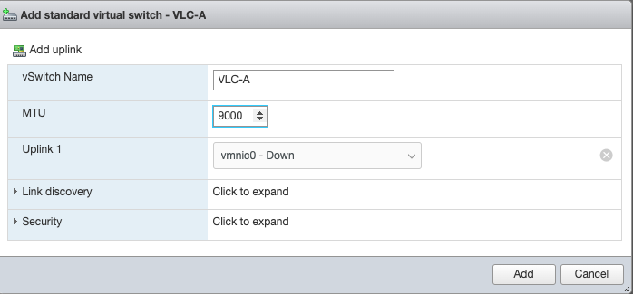

1. Click Add

**[Step 2] Configure VLC Portgroup**

1. Add a new port group
2. Name the portgroup VLC-A-PG
3. Set VLAN ID to 4095 (Trunk all VLAN)
4. Set virtual switch to VLC-A
5. Open security and set all to accept
6. Click Add

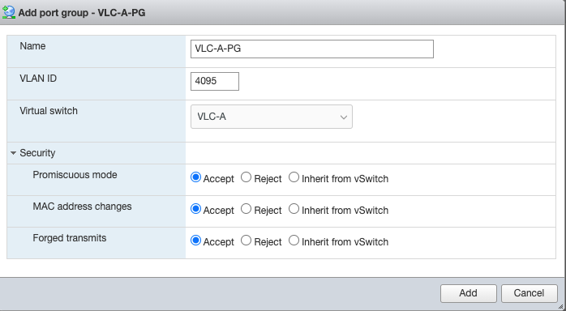

## Task 2a: Deploy nested jump host

##### In this task we will deploy and configure a nested Windows Server 2019 jump host. This task must be repeated for each additional Holodeck instance deployed on a host

**[Step 1] Create new virtual machine**

1. From the virtual machine tab select Create/Register VM
2. Select create a new virtual machine
3. Name the VM Main Console-A (In this Holodeck example we are using “Holo-Console-A”)
4. Set OS family to Windows
5. Set OS Version to Windows Server 2019

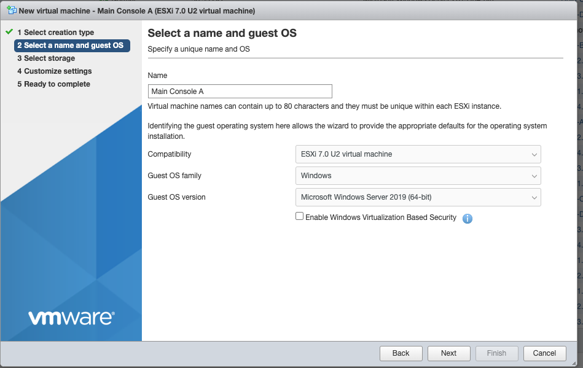

1. Click Next
2. Select storage appropriate for your ESXi host then click next

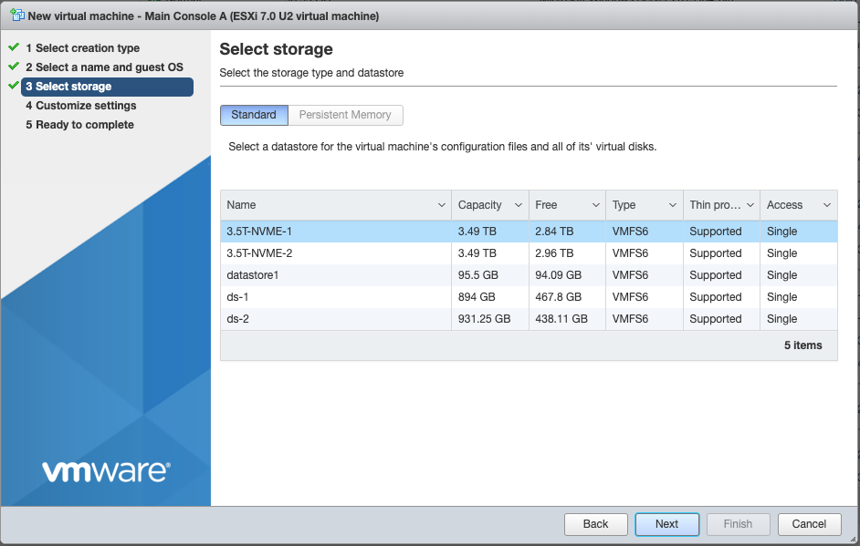

1. Defaults for CPU, Memory and Hard Disk will usually suffice
2. Set network adapter 1 to your external facing portgroup (VM Network in this example)
3. Select VMXNET 3 as adapter type

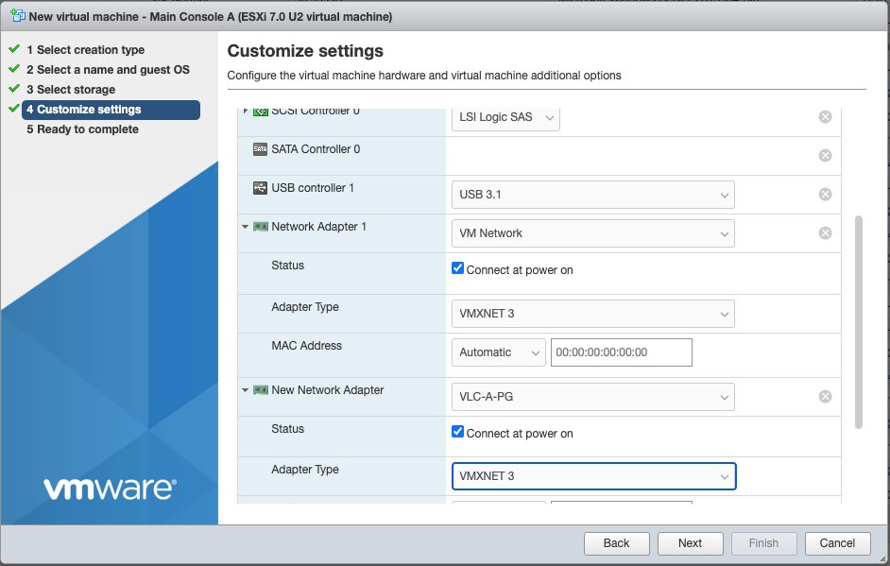

1. Click Add network adapter
2. Connect to VLC-A-PG Portgroup (replace VLC-A-PG with VLC-B-PG, etc as needed for additional instances)
3. Select VMXNET 3
4. Click Next

1. Click CD/DVD Drive and set to Datastore ISO
2. Select the appropriate location for your Windows Server 2019 ISO (In this example we have the Windows Server 2019 ISO on ds-1

1. Click Next
2. Click Finish

## Task 2b: Configure jump host networking

##### In this task we will configure networking on the Windows Server 2019 jump host

**[Step 1] Set external networking**

1. Open Windows control panel
2. Select Network and Internet
3. Select your external facing interface and configure outward facing IP, gateway and DNS

1. Select the VLC facing interface and click properties
2. Click Configure under the interface

1. Click Advanced, then scroll down to VLAN ID
2. Set VLAN ID 10, then ok

1. Click properties, then Internet Protocol Version 4, then properties

1. Set IP address to 10.0.0.220, netmask 255.255.255.0, DNS 10.0.0.221

1. Click OK, then close

## Task 3a: Deploy PFsense Lab Gateway

##### In this task we will deploy a PFsense router to act as a lab gateway. This step requires you have downloaded [PFsense CE 2.6](https://atxfiles.netgate.com/mirror/downloads/pfSense-CE-2.6.0-RELEASE-amd64.iso.gz)

**[Step 1] Create new virtual machine**

1. From the virtual machine tab select Create/Register VM
2. Select create new VM
3. Name the VM Lab-Router-A (or similar)
4. Select OS Other, and Free BSD 13 or later 64 bit

1. Select Storage

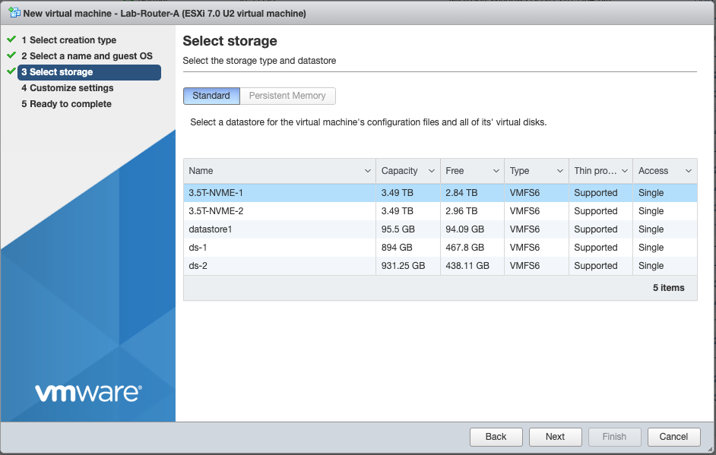

1. Default CPU, memory and disk are adequate
2. Set SCSI Controller to LSI Logic Parallel
3. Configure Network Adapter 1 to point to your external network. 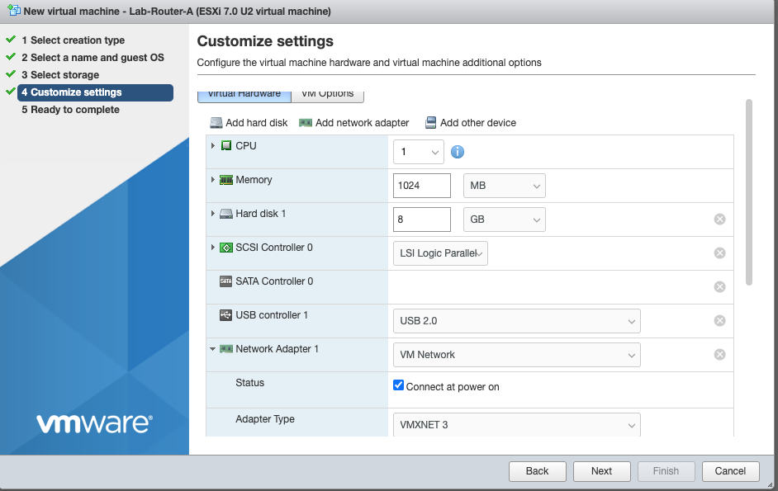
4. Add a second network adapter and connect to VLC-PG-A

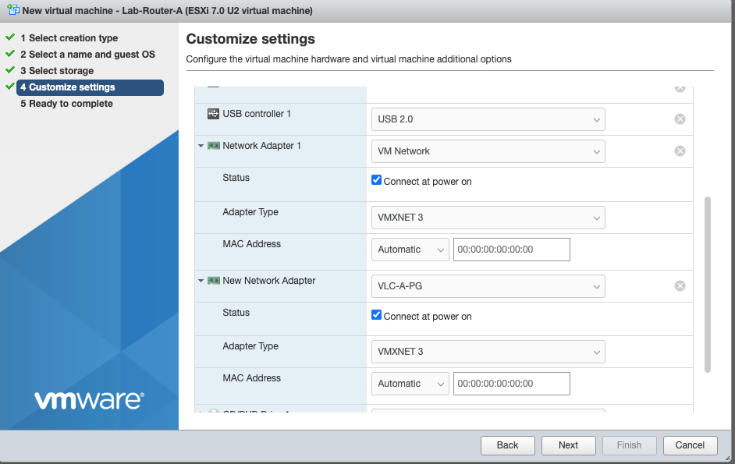

1. Set CD to Datastore ISO and select location of the PFsense iso

1. Click Next
2. Your deployment should look like this

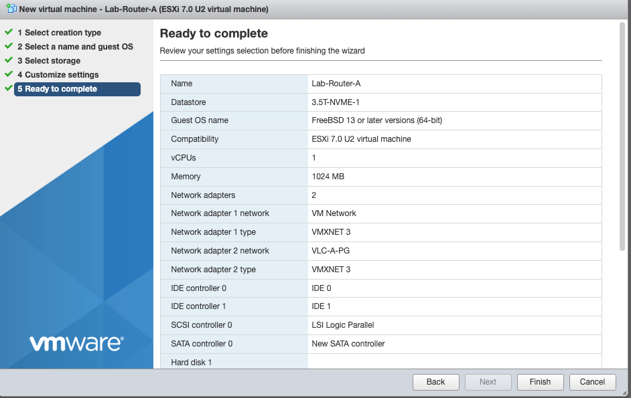

1. Click Finish
2. Power on the VM
3. Open a console into the VM
4. Accept the EULA

1. Select install

1. Select continue with default keymap

1. Select Auto (UFS) BIOS

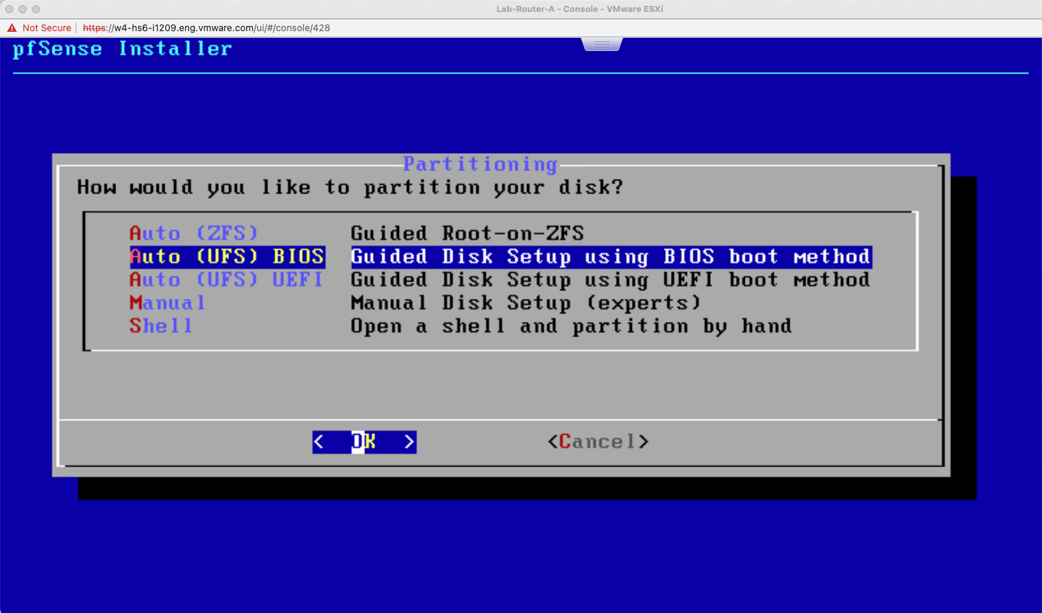

1. Select Proceed with install
2. Select no when asked if you would like to open a shell

1. Select reboot

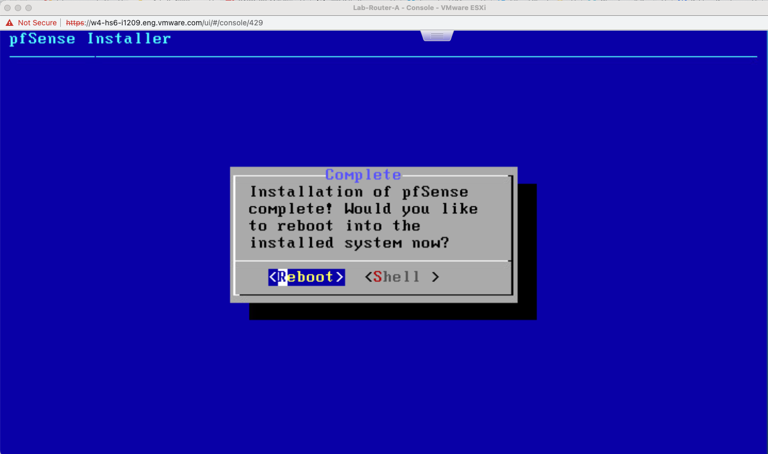

**[Step 2] Configure PFsense**

This step will configure PFsense for your environment.

1. After initial boot, your PFsense config should look like the following

1. From your vSphere client, determine which interface (using mac address) connects to your external network. This will be your “WAN” interface later. In this example we can see that the vmx0 interface with MAC ending in c4:4f is connected to our external network

1. For the VLC Holodeck configuration, we need the inside (LAN) interface to connect on VLAN 10. We will configure vmx0 for VLAN use. Select y on the PFsense console to configure VLANs

1. Enter the parent interface for the new VLAN. In this example our LAN interface will be on vmx1, so we will enter vmx1and enter

1. Enter VLAN tag 10

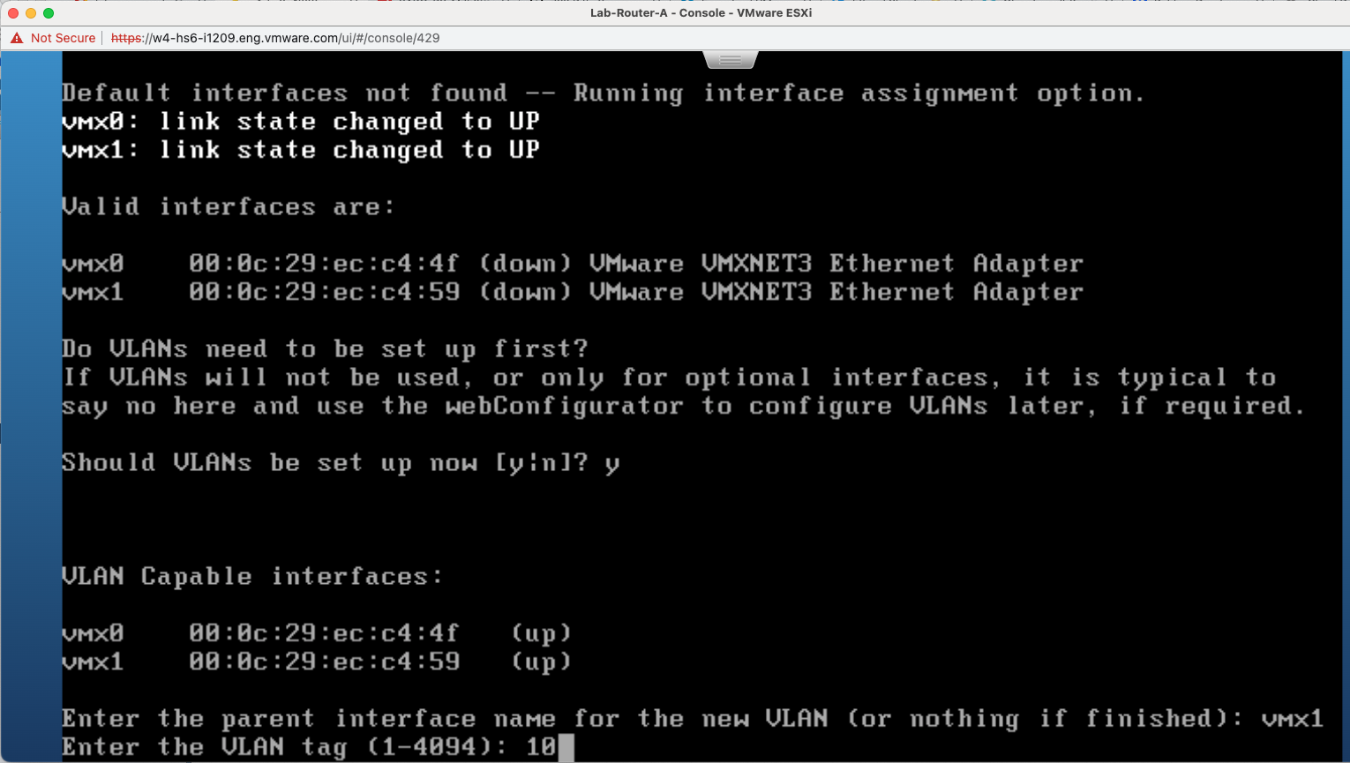

1. Hit enter when asked for parent interface for next VLAN (signaling we do not need another VLAN)

1. Enter the interface that is connected to your external network for WAN interface. In this example, the WAN interface was determined to be on vmx0

1. Enter the interface for the LAN interface. In this example we need to select the vmx1.10 interface to enable VLAN10

1. We do not need an optional interface, so hit enter

1. Your output should look like this

1. Enter y to proceed. PFsense will reconfigure and reboot
2. After reboot, select 2 to set IP addressing

1. Select 1 for WAN interface . Configure as per your environment. In this example, we will use a fixed /28 IPv4 address (no DHCP) and no IPv6

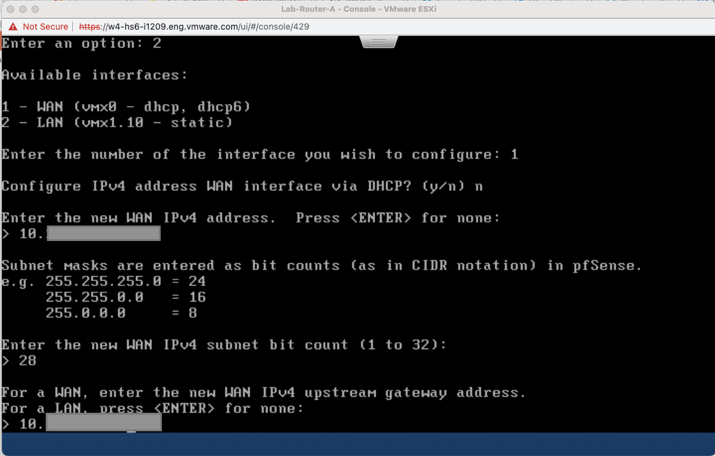

1. Select yes for HTTP for web configurator

1. Press enter to continue

1. Select option 2 to set IP for LAN interface, then 2 to select LAN

1. Set LAN interface to 10.0.0.1/24. You do not need an upstream gateway, IPv6 info or DHCP server

1. Your end result should look like this

## Task 4: Deploy VCF using VLC

##### In this task we deploy a nested VCF instance using VCF Lab Constructor. This task documentation is designed to act as an extension to the VCF Lab Constructor manual that comes with VLC. This step assumes you have downloaded VLC from <https://tiny.cc/getVLCBits> and unzipped to c:\vlc on your jump host

**[Step 1] Add licensing info to EMS json**

1. Open c:\vlc\ NOLIC-44-TMM-vcf-ems-public.json with your editor
2. Within this file you will find and replace <INSERT LIC> with a valid license in 4 locations.
   * esxiLicense
   * nsxtLicense
   * vSAN licenseFile
   * vCenter licenseFile

1. Save the edited file as c:\vlc\ LIC-44-TMM-vcf-ems-public.json

**[Step 2] Download Cloud Foundation 4.4.1 Cloud Builder**

1. Access [VMware Customer Connect](https://customerconnect.vmware.com/downloads/details?downloadGroup=VCF441&productId=1252&rPId=88408) to download Cloud Foundation 4.4.1 Cloud Builder. Note: You will need a valid login to VMware Customer Connect to download cloud builder

1. Place the Cloud Builder OVA in C:\Cloud Builder (or similar directory)

**[Step 3] Run VLC**

1. While logged in to your jump host as administrator, right click on VLCGui.ps1 and click Run with Powershell (in this example I am using a pre-release version called VLCGuiHH-2.ps1)

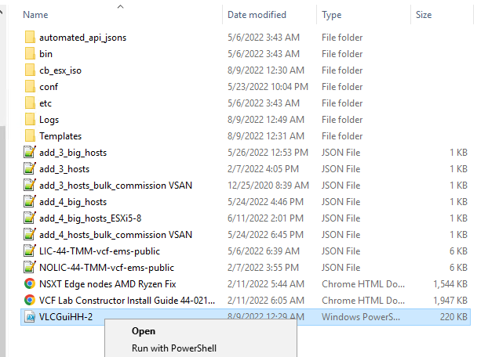

1. Click Automated on the VLC UI

1. Click on VCF EMS JSON field

1. Select the modified EMS json with your license keys, then Open

1. Enter the address of the lab gateway created in previous steps (10.0.0.1) in the Ext GW field
2. If your lab requires use of DNS other than 8.8.8.8, enter in Ext DNS
3. Leave Mgmt Net CIDR, Mgmt GW and CB IP default
4. Leave “Use CB ESXi” checked
5. If you plan to deploy more than one lab on this physical host, add a unique name in the Prefix for VMs field. In this example we use Holo-A
6. Leave Host/CB Password, NTP IP and DNS IP at default
7. Leave Full Domain at default
8. Check Deploy Edge Cluster
9. Leave NSX S-net default at 10.1.0.0/16 (This is used for the Holodeck labs later)
10. Select Deploy Workload Mgmt (Enables Tanzu/Container workloads later)
11. Select Deploy AVN (used for vRealize and other infrastructure later)

1. Enter hostname, username and password for your ESXi host

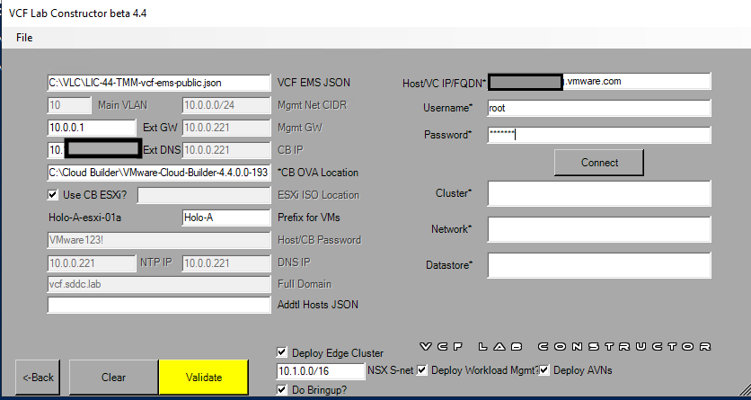

1. Click Connect
2. Select the portgroup and datastore you will use for this deployment. In this example we VLC-A-PG we created earlier

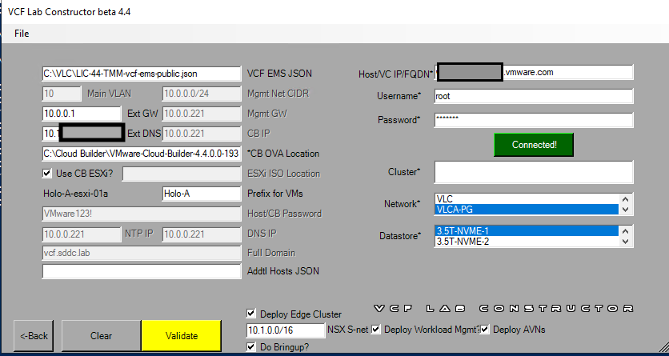

1. Click Validate
2. Your results should look like

1. Click Construct
2. VLC will deploy your configuration. The process takes about 3 hours

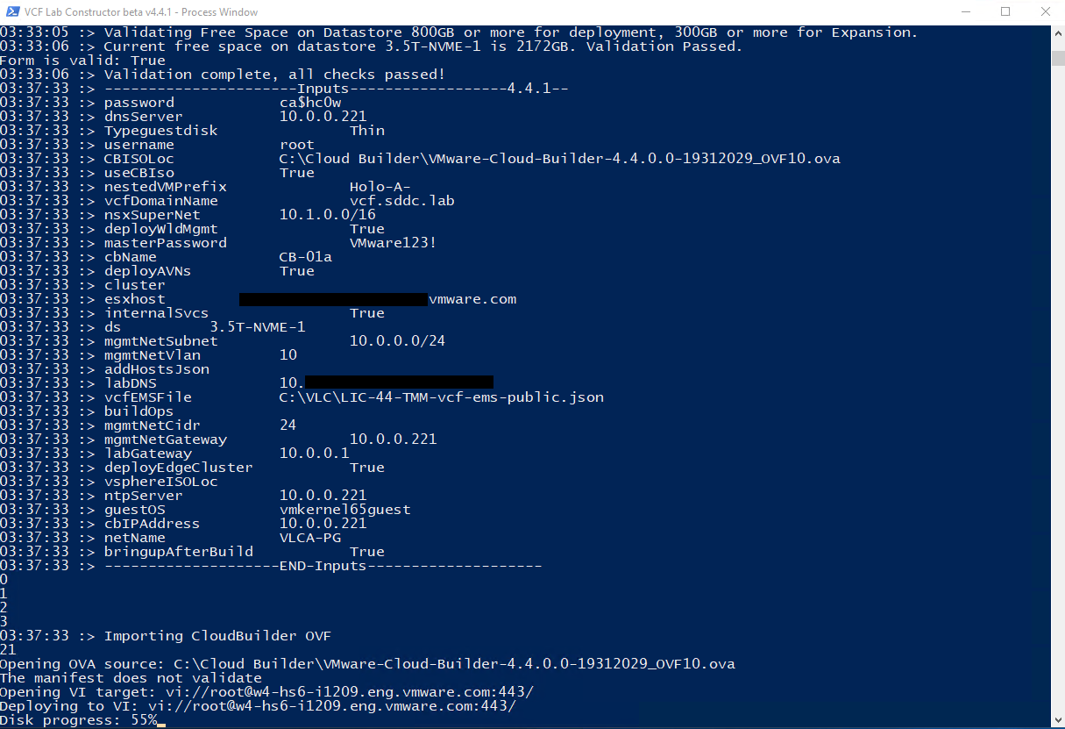

1. When complete, VLC will advise the user to click enter then access SDDC Manager via web browser

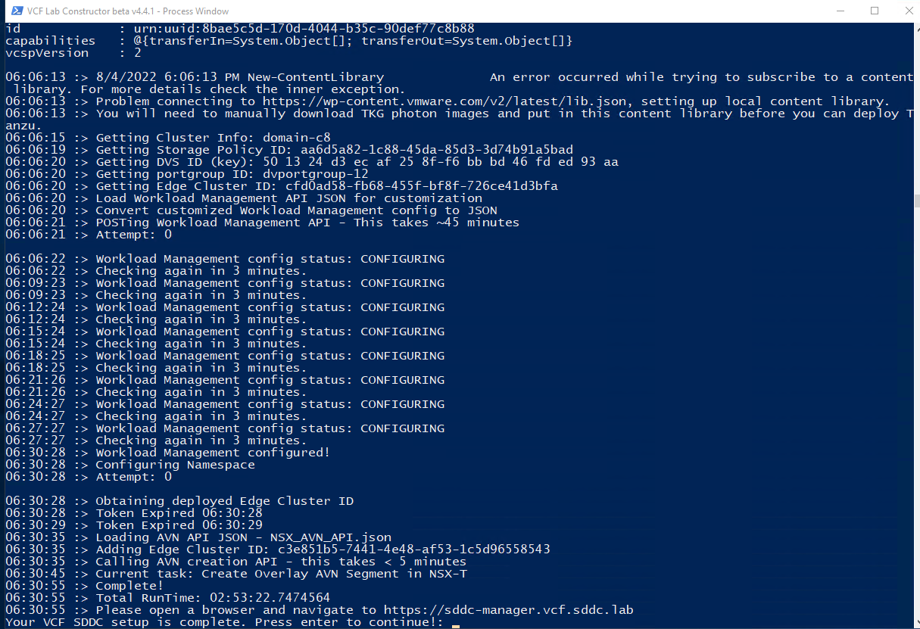

1. Open a Chrome browser and click on the SDDC Manager bookmark
2. Ignore security warnings (click advanced and proceed to sddc-manager.vcf.sddc.lab)
3. Ignore security warnings (click advanced and proceed to vcenter-mgmt.vcf.sddc.lab as SDDC Manager use vCenter SSO for authentication)
4. Login as [adminstrator@vsphere.local](mailto:adminstrator@vsphere.local) password VMware123!
5. Uncheck the VMware CEIP box
6. Your result should look like

